Security Safe

Summary Datasheet

By the **C**onnected **O**ptical **L**ogistics and **I**nfrared **N**etworks Company.

March 5, 2025.

The safe consists of two items: an interface & a secure box. The interface is to the LEFT of the secure box.

## Secure Box

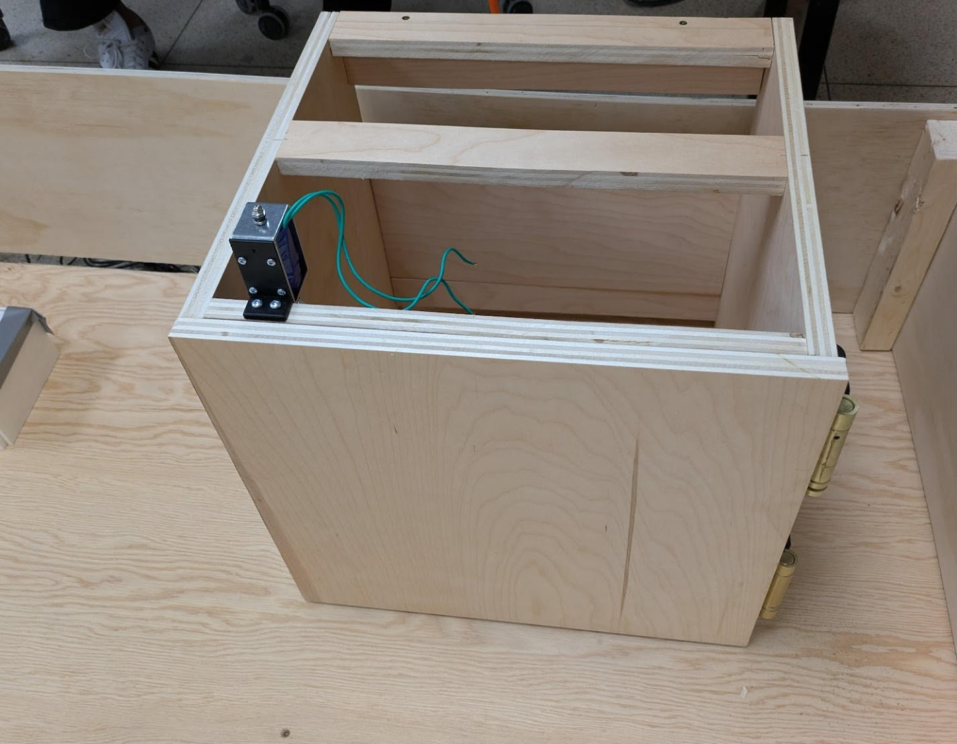

*NOTE: The secure box can be opened by pulling the knob/end of the electromagnet. This is an allowed method of entry but will set off the alarm (see ALARM section)*.

## **Interface**

The safe front interface knob is available as a STL and STP file.

### **Interface Operation**

The safe is always reset to “0”. This is done every time a run is restarted (that is – whether you reset the points or not, the safe is reset to 0 on each run).

To enter the code:

* Turn **clockwise to the first digit.**
* Turn **counter-clockwise past zero** until reaching the second digit.
* Turn **clockwise past zero** until reaching the final digit. The safe opens once the final digit is reached.

When the safe is open, the light illuminating the selected digit will go out. I'll also have a status light in the upper right corner.

The safe is reset and locked again by rotating clockwise to zero.

## **Supported Codes**

The safe supports two codes. The codes are:

1. An INSTALLER code set by the factory, which is 4-5-3 . If this code is used it sets off the alarm as is not designed for regular usage.
2. A USER code which changes and is normally provided on a QR code for safe keeping.

## **Alarm**

The safe interfaces to the **general alarm system** (with the 45 second delay). The safe will trip the alarm in the following conditions:

1. The installation code is used.
2. The safe is opened without being unlocked.

It the general alarm system is powered off, the alarm will be inactive.

## **COSYS**

An IR LED is present on the safe, which uses the COSYS protocol to indicate the current state of the wheel and the unlock/lock status.

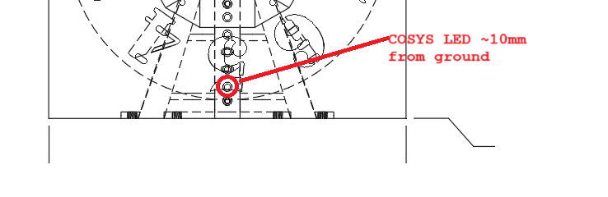

See the COSYS Protocol Documentation for more details of COSYS, this section includes only the device-specific settings.

The message transmitted by the device is as follows:

SAF X:L CC\n

The message is ALWAYS 11 characters long, including the \n (0x0A hex) character as required by the COSYS protocol. In the above, the variable parts of the message are:

X = Current digit in ASCII (0-9)

L = (L)ocked or (U)nlocked

CC = COSYS required checksum (can be ignored)

Some example message is as follows in ASCII:

SAF 0:L 32\n

SAF 5:L 37\n

SAF 7:U 2C\n

In the above messages, this would be for example starting with the digit set at 0 (the initial state) with the state locked. It follows by the user rotating to 5, and eventually rotating to 7 with the safe unlocking.

Revision History

March 5, 2025: Initial Release